Early-Window GPU Thermal Prediction and Adaptive Cooling Control in Data Centers

Ganesh H K
Department of Electronics and Communication Engineering,
Dr. Ambedkar Institute of Technology, Bengaluru, India
Smita S M
Department of Electronics and Communication Engineering,
Dr. Ambedkar Institute of Technology, Bengaluru, India
B G Srushti
Department of Electronics and Communication Engineering,
Dr. Ambedkar Institute of Technology, Bengaluru, India

ganeshkgowda25@gmail.com smitashashidhar@gmail.com bgsrushti29@gmail.com

Abstract— Graphics Processing Unit (GPU) intensive Artificial Intelligence and High-Performance Computing workloads create challenges for data-centre thermal management. This study investigates whether early GPU telemetry can predict the eventual peak temperature of an individual job and help guide cooling decisions. Using the MIT SuperCloud dataset, we evaluated XGBoost, Random Forest, Decision Tree, and regularized Linear Regression on 2,508 unique jobs across nine observation windows ranging from 10 to 600 s. XGBoost achieved R² = 0.9294 using the 600-s observation window, with a median single-record inference time of 2.445 ms and a median model size of 1,914.6 KB across the tested windows. Although Random Forest achieved slightly higher (R^2) at several longer windows, XGBoost offered a practical balance between prediction accuracy and computational cost. A three-layer software framework was developed to combine predicted peak temperature, current temperature, safety thresholds, and Pulse-Width Modulation (PWM) commands, with a persistence filter and an immediate safety override. An offline comparison using a normalized PWM-runtime energy proxy estimated reductions of 88.61–93.89% relative to an always-100% PWM baseline. These estimates are not measurements of actual electricity savings, and the controller has not been validated on physical cooling hardware. The results demonstrate the potential of early-job thermal prediction and establish a basis for future hardware-based evaluation.
Keywords—data center cooling, GPU thermal prediction, XGBoost, predictive cooling , energy efficiency, MIT Supercloud, HPC telemetry

I. INTRODUCTION
Artificial Intelligence (AI) and high-performance computing (HPC) data centres consume increasing amounts of electricity, with cooling accounting for an estimated 7-30% of facility energy use in some cases [1]. Global data-centre electricity consumption reached approximately 415 TWh in 2024 and is expected to rise with AI adoption [1]. Predicting thermal behaviour early could help cooling systems respond proactively rather than relying only on current temperatures.
The MIT Supercloud Dataset provides detailed GPU telemetry, while previous studies highlight variations in GPU workload behaviour and explore machine-learning-based power forecasting and predictive cooling [2]–[10]. Building on this work, the present study investigates whether early-job telemetry can predict an individual GPU job’s eventual peak temperature.
Four models—XGBoost, Random Forest, Decision Tree, and regularized Linear Regression—are evaluated across nine observation windows from 10 to 600 s. XGBoost achieves an R² of 0.9294 at 600 s, with a median inference time of approximately 2.445 ms and a model size of 1,914.6 KB. The selected model is integrated into a three-layer cooling framework combining temperature prediction, measured-temperature monitoring, a safety override, a three-

consecutive-sample persistence filter, and pulse-width modulation (PWM) control. Cooling strategies are compared using a normalized PWM-runtime energy proxy; the results represent estimated comparisons, not measured electricity savings.
II. RELATED WORK
A. MIT SuperCloud Dataset and GPU Workload Characterization
Samsi et al. introduced the MIT Supercloud Dataset, providing job-level information and GPU telemetry, including utilization, power, and temperature [2]. Li et al. characterized GPU workloads in a production HPC environment, highlighting variations in resource utilization across jobs [3]. These studies motivate using early-job telemetry to predict eventual peak GPU temperature.

B. Machine Learning for GPU and Data-Centre Forecasting
Mughees et al. explored LSTM, GRU, and one-dimensional CNN models for short-term GPU power forecasting using MIT Supercloud telemetry [4]. Wang et al. proposed a regime-adaptive ensemble for electrical-load forecasting [5], while another study applied sequence-to-point knowledge distillation to reduce forecasting-model complexity [6]. Unlike these approaches, the present work predicts job-level peak GPU temperature from early execution data.

C. Predictive Thermal Management and Cooling Control
Lazic et al. investigated data-driven model-predictive control for data-centre temperature and airflow management [7]. Liu et al. used LSTM-based temperature and humidity forecasts to adjust fan speeds and chilled-water valves [8]. In contrast, this work combines predicted peak temperature with current GPU temperature to guide job-level cooling decisions.

D. Computing and Cooling Energy Management
Zhou et al. proposed LEES to coordinate server operations and cooling settings [9], while Cao et al. presented a physics-informed digital-twin approach for capacity planning that considers energy and carbon emissions [10]. This work instead compares job-level cooling strategies using a normalized PWM-runtime energy proxy, not measured electricity savings.

E. Research Gap and Present Work
Existing studies address workload characterization, power forecasting, predictive cooling, or facility-level energy management. This work evaluates four machine-learning models across nine observation windows (10–600 s) to predict individual jobs’ eventual peak GPU temperatures. The selected model supports a three-layer cooling framework combining prediction, measured-temperature thresholds, a safety override, a three-consecutive-sample persistence filter, and PWM control. Prediction accuracy, computational efficiency, and proxy-based cooling energy are evaluated.
The main contribution is integrating early job-level peak-temperature prediction with safety-aware cooling control

III. DATASET AND DATA INTEGRITY VERIFICATION
A. Dataset Description
This study uses the MIT Supercloud dataset’s nvidia_smi.csv [2], containing NVIDIA Tesla V100 GPU telemetry collected from 5 February to 3 March 2021. The raw dataset contains approximately 477.6 million records spanning 26 days. Grouping by job ID, node ID, and GPU index yielded 2,739 job–GPU records across 2,508 unique jobs. Nine observation windows, ranging from 10 to 600 s, were created to predict each job’s eventual peak GPU temperature using early telemetry, including power, utilization, memory, and temperature measurements.

B. Data Validation and Integrity
The raw file was processed in chunks to manage memory usage. Two malformed records were excluded, and no duplicates were detected during chunk-based checks. The checked job–GPU records showed no suspicious internal time gaps, and telemetry values remained within expected physical ranges. All nine final window files contained 2,739 records, with no missing or infinite numeric values. PCIe link width was consistently 16 across the checked raw data. These checks support the consistency of the data used for model evaluation.
IV. METHODOLOGY
A. Layer 1: Model Training and Prediction
XGBoost [11], Random Forest, Decision Tree, and regularized Linear Regression were trained independently for each observation window. Ridge and Lasso were compared for the linear approach, with the selection made using training-only cross-validation. The 2,508 unique job IDs were divided once into 2,131 training jobs (2,327 job–GPU records) and 377 test jobs (412 records). The same split was reused for every model and window; validation confirmed zero job-ID overlap between training and test sets.
Hyperparameter selection used five-fold GroupKFold within the training jobs [12]. Twenty randomized configurations were evaluated per window for XGBoost, Random Forest, and Decision Tree. Ridge and Lasso were each searched over 21 logarithmically spaced regularization values. Model predictions were assessed on the untouched test set using R², mean absolute error (MAE), and root mean squared error (RMSE):
R² = 1 − Σᵢ(yᵢ − ŷᵢ)² / Σᵢ(yᵢ − ȳ)²
MAE = (1/n) Σᵢ |yᵢ − ŷᵢ|
RMSE = √[(1/n) Σᵢ (yᵢ − ŷᵢ)²]
Here, yᵢ is the actual full-job peak temperature, ŷᵢ is its prediction, ȳ is the mean actual peak temperature, and n = 412 test records for each window. Benchmarking used five warm-up predictions followed by 50 single-record predictions per saved model; median latency and saved model-file size were recorded. Timings are local, within-environment comparisons rather than hardware-independent performance guarantees.
B. Layer 2: Thermal Decision and Safety Logic
The predicted peak and current sensor temperature are independently mapped to tiers: Low (<35°C), Medium (35–<45°C), High (45–<71°C), and Critical (≥71°C). The controller takes the more severe tier. A new tier becomes active only after the same candidate appears in three consecutive updates, which limits switching caused by transient readings. If the measured temperature reaches 82°C, the controller immediately forces Critical and bypasses the persistence filter. The implementation was tested in software with example feature and sensor values; no physical fan was driven.
C. Layer 3: PWM Mapping
The PWM table was recalibrated using training jobs only. Peak-temperature quartiles (35°C, 45°C, and 71°C) define the four regions. For each region, average GPU power was normalized by the Critical-region average and converted to a PWM percentage, with a 30% minimum. The resulting commands are Low 30%, Medium 30%, High 47.8%, and Critical 100%. This is a data-derived heuristic mapping: GPU power is used as a proxy for relative cooling demand, not as a measurement of fan power or speed.

D. Cooling-Energy Proxy
The dataset contains no direct fan, pump, chiller, or facility cooling-power measurements. We therefore use a normalized proxy informed by the fan affinity law, which states that fan input power varies approximately with the cube of rotational speed when fan size, air density, and comparable operating conditions are held constant [13]. Because rotational speed was not measured, PWM duty cycle is assumed to approximate normalized fan speed:

E_proxy,i = (uᵢ / 100)³ × tᵢ

Here, uᵢ is the assigned PWM percentage and tᵢ is the job runtime in seconds. The proxy is summed across held-out job–GPU records; it is not joules or kilowatt-hours. Savings versus a reference are calculated as 100 × (1 − proxy_predictive / proxy_reference). The three offline strategies are predicted-tier PWM, a stepped reference (40/60/80/100% using the actual full-job peak tier), and always-100% PWM. Since the stepped reference uses the eventual true peak, it is an offline benchmark, not a deployable controller.
V. RESULTS AND DISCUSSION

Fig. 1 compares the grouped-test R², MAE, and RMSE of the four models across nine observation windows. XGBoost R² improves from 0.6136 at 10 s to 0.9294 at 600 s; its MAE falls from 7.108°C to 2.414°C and RMSE from 10.154°C to 4.342°C. Longer windows provide more information and improve peak-temperature prediction, but delay the point at which the prediction becomes available.
Fig. 1 Grouped-test comparison of (a) R², (b) MAE, and (c) RMSE across four machine-learning models and nine observation windows.

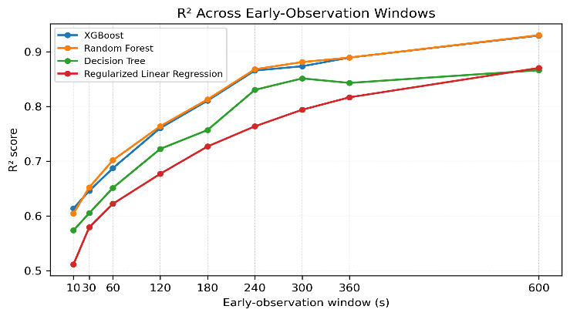
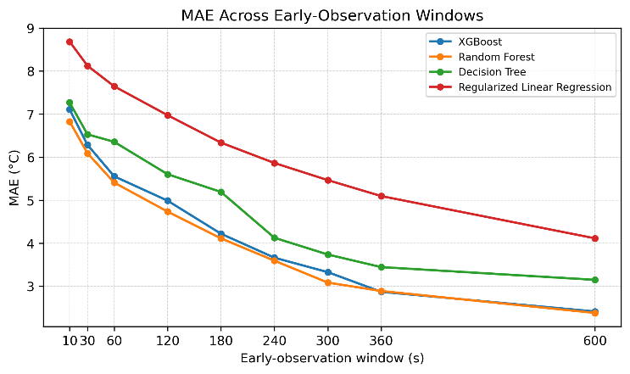
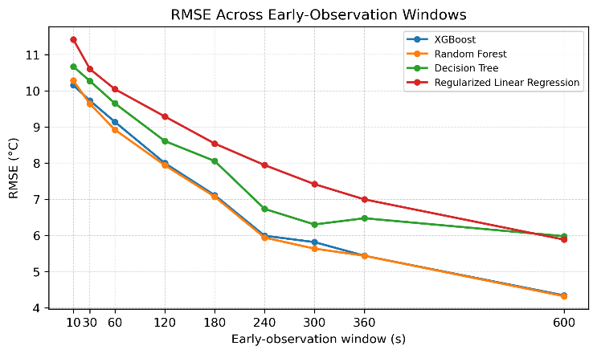 Random Forest achieved slightly higher R² than XGBoost at several longer observation windows. However, the differences were small, and no statistical significance testing was performed. Therefore, XGBoost was selected based on its balance between prediction accuracy and computational cost, rather than being the most accurate model at every window.

TABLE I. MEDIAN COMPUTATIONAL COST ACROSS NINE
WINDOW-SPECIFIC MODELS
Algorithm | Single-record inference (ms) | Model size (KB)
Decision Tree | 1.145 | 10.7
Regularized Linear | 1.279 | 1.8
XGBoost | 2.445 | 1914.6
Random Forest | 22.463 | 15775.3

Decision Tree and Linear Regression were the smallest and fastest models, but their accuracy was generally lower. Random Forest was marginally more accurate at several windows; however, its median inference time was about 9.2 times that of XGBoost and its median model size about 8.2 times larger. XGBoost was therefore selected as a practical accuracy–cost compromise, not because it was the most accurate model at every window.
The controller loaded all nine XGBoost artifacts in the software test. Repeated identical candidate tiers caused a normal tier transition after the third update, while an example measured temperature of 84°C immediately triggered Critical and a 100% PWM command. These tests verify the implemented decision logic only; they do not demonstrate physical cooling performance.

VI. COOLING-ENERGY PROXY RESULTS
Table II summarizes the offline proxy comparison. Across windows, the predictive-tier assignment was 88.61–93.89% lower than the always-100% reference and 78.40–88.41% lower than the stepped reference under the chosen proxy. These large percentages result from assigning lower PWM commands to many records and applying the cubic PWM assumption. They do not establish that the same cooling could safely be delivered or that actual electrical consumption would fall by these amounts.

TABLE II. ESTIMATED REDUCTION IN THE NORMALIZED PWM-RUNTIME PROXY (%)
Window (s) | vs. always 100% PWM | vs. stepped reference
10 | 93.75 | 88.16
30 | 93.50 | 87.67
60 | 92.08 | 84.98
120 | 93.89 | 88.41
180 | 91.02 | 82.96
240 | 90.11 | 81.25
300 | 88.61 | 78.40
360 | 89.38 | 79.87
600 | 89.17 | 79.46

VII. LIMITATIONS AND FUTURE WORK
The evaluation uses historical telemetry from one GPU generation (Tesla V100) and a job-ID-disjoint random split; future-period generalization was not established. The controller was validated in software and was not connected to a physical fan or sensor. The PWM curve is heuristic, and PWM duty cycle was not calibrated against fan RPM or electrical power. The energy proxy also evaluates predicted-tier assignments offline rather than replaying every live sensor update through the complete persistence controller. A physical evaluation should measure fan speed, cooling-device power, temperature response, and safety outcomes while comparing policies under matched thermal constraints. The method’s specific contribution is the early-job peak-temperature target, multi-window job-disjoint evaluation, deployment-cost comparison, and safety-aware control pipeline; predictive cooling in general is not claimed as new.
VIII. CONCLUSION
This work evaluated early-window prediction of GPU peak temperature using four model families and nine observation windows. XGBoost achieved R² = 0.9294 at 600 s and offered substantially lower inference cost and model size than Random Forest. A three-layer software controller combined prediction with current temperature, persistence filtering, a safety override, and PWM lookup. The proxy analysis indicates a potential direction for reducing reliance on continuous maximum PWM, but real energy savings and thermal safety must be established through hardware measurement.

IX. ACKNOWLEDGMENT
Project Guide: The authors sincerely thank Dr. Mala Sinnoor, Assistant Professor, Dr. Ambedkar Institute of Technology, Bengaluru, for her guidance and support throughout this project.
LLM Assistance: LLM-based tools were used to assist in writing and refining parts of this paper and supporting tasks. The authors take responsibility for the final content and reported results.

X. REFERENCES

[1] International Energy Agency, *Energy and AI*. Paris, France: IEA, 2025. [Online]. Available: https://www.iea.org/reports/energy-and-ai.
[2] S. Samsi et al., “The MIT Supercloud Dataset,” in *Proc. IEEE High-Performance Extreme Computing Conf. (HPEC)*, 2021, pp. 1–8, doi: 10.1109/HPEC49654.2021.9622850.
[3] B. Li et al., “AI-Enabling Workloads on Large-Scale GPU-Accelerated System: Characterization, Opportunities, and Implications,” in *Proc. IEEE Int. Symp. High-Performance Computer Architecture (HPCA)*, 2022, pp. 1224–1237, doi: 10.1109/HPCA53966.2022.00093.
[4] M. Mughees, Y. Li, Y. Chen, and Y. R. Li, “Short-Term Load Forecasting for AI-Data Center,” in *Proc. IEEE Power & Energy Society General Meeting (PESGM)*, 2025, doi: 10.1109/PESGM52009.2025.11225317.
[5] Z. Wang, Y. Zhang, L. Wang, and Y. Lin, “Regime-Adaptive Weighted Ensemble Learning for Computing-Driven Dynamic Load Forecasting in AI Data Centers,” *arXiv preprint* arXiv:2604.27207, 2026.
[6] L. Wang, J. Chen, F. Sui, Y. Zhang, and D. Shi, “Deployment-Efficient Short-Term Load Forecasting in AI Data Centers via Sequence-to-Point Knowledge Distillation,” *arXiv preprint* arXiv:2605.00681, 2026.
[7] N. Lazic et al., “Data Center Cooling Using Model-Predictive Control,” in *Advances in Neural Information Processing Systems*, vol. 31, 2018, pp. 3818–3827.
[8] J. Liu, R. Fan, Z. Li, N. Harnpornchai, and J. Qian, “Proactive Cooling Control Algorithm for Data Centers Based on LSTM-Driven Predictive Thermal Analysis,” *Applied System Innovation*, vol. 9, no. 1, Art. no. 21, 2026, doi: 10.3390/asi9010021.
[9] B. Zhou, X. Song, X. Shi, Y. Lu, and S. Hu, “Bridging Server and Cooling: Toward Effective Energy Management in Data Centers,” in *Proc. IEEE 25th Int. Conf. Parallel and Distributed Systems (ICPADS)*, 2019, pp. 45–52, doi: 10.1109/ICPADS47876.2019.00015.
[10] Z. Cao et al., “Adaptive Capacity Provisioning for Carbon-Aware Data Centers: A Digital Twin-Based Approach,” *IEEE Trans. Sustainable Computing*, vol. 10, no. 4, pp. 730–743, 2025, doi: 10.1109/TSUSC.2025.3526192.
[11] T. Chen and C. Guestrin, “XGBoost: A Scalable Tree Boosting System,” in *Proc. 22nd ACM SIGKDD Int. Conf. Knowledge Discovery and Data Mining*, 2016, pp. 785–794, doi: 10.1145/2939672.2939785.
[12] F. Pedregosa et al., “Scikit-learn: Machine Learning in Python,” *Journal of Machine Learning Research*, vol. 12, pp. 2825–2830, 2011.
[13] U.S. Department of Energy and Air Movement and Control Association International, Inc., Improving Fan System Performance: A Sourcebook for Industry. Washington, DC, USA, Apr. 2003. [Online]. Available: https://www.energy.gov/sites/prod/files/2014/05/f16/fan_sourcebook.pdf

